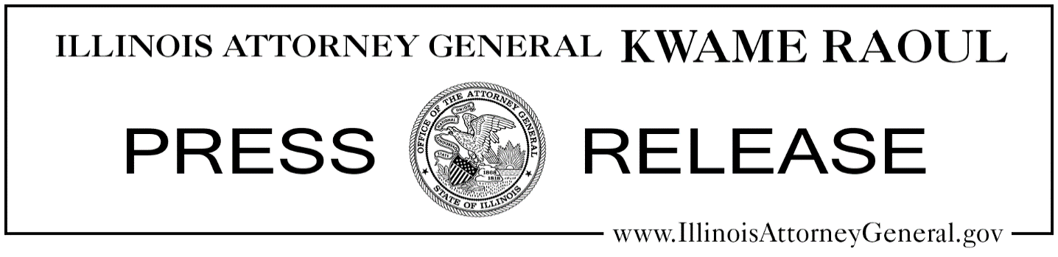
For Immediate Release: Contact:
March 29, 2023 PressOffice@ilag.gov
@ILAttyGeneral

ATTORNEY GENERAL RAOUL URGES FEDERAL GOVERNMENT TO ENSURE ROBUST ACCESS TO ASYLUM
Chicago – Attorney General Kwame Raoul, as part of a coalition of 12 attorneys general, issued a letter on Tuesday raising concerns with a proposed rule that would put more restrictive standards in place for those seeking asylum.
In their comment letter, Raoul and the attorneys general support the federal government’s efforts to better ensure lawful, safe and orderly mechanisms for migrants seeking safety in the United States but urge the federal government to continue to explore commonsense solutions to both protect access to asylum and ensure a more efficient and orderly process.
“While our system of applying for asylum needs reform, any overhaul must ensure the safety of families fleeing violence and oppression,” Raoul said. “I will continue to support efforts to protect asylum seekers from any further harm as they go through the process of seeking safety in the United States.”
Raoul and the coalition note the current proposed rule is inconsistent with key aspects of the Immigration and Nationality Act and could potentially harm already vulnerable asylum seekers and the states that welcome them.
Under the current proposed rule, the federal government – in anticipation of increased asylum claims at the border when Title 42 is lifted on May 11, 2023 – would largely require migrants to follow the rule’s specified pathways in order to secure protection in the United States. As part of the proposal, the federal government is currently set to put more restrictive standards in place for those seeking asylum. For example, individuals entering the United States at the southern border, except in limited circumstances, would be presumptively ineligible for asylum unless they applied for and were denied protection in at least one country that they traveled through prior to their arrival in the U.S., or used the CBP One online application to make an appointment to present themselves to immigration officials.
In the comment letter, the coalition urges the federal government to reconsider aspects of the proposed presumption of ineligibility in order to avoid, or at least mitigate, any potential harms to asylum seekers and the states that welcome them.
In their letter, Raoul and the coalition state:
- Provisions of the current proposal conflict with the more expansive protections guaranteed under the Immigration and Nationality Act.
- If asylum is improperly restricted, it will limit the ability of asylum seekers to integrate into state workforces and potentially strain state-funded services.
- The proposed rule would unfairly harm many asylum seekers, particularly those with fewer resources.
Joining Raoul in filing the comment letter are the attorneys general of California, Delaware, the District of Columbia, Massachusetts, Michigan, Minnesota, Nevada, New York, Rhode Island, Vermont and Washington.
-30-

